**Smart Home Entrance**

**Abstract**

The aim of this project is to simulate smart home entrance system. There are two main objectives of this system: to provide safety in case of emergency and to provide with a high level of comfortability for people living in the building. For the first objective, the idea is to have all the necessary sensors, which help to detect hazardous situations. Human detecting sensors adjust the lights according to the presence of people. Also, security is provided by entrance doors and door phone system, using passwords and RFID keys, accordingly. The

We will consider the case when the burglars will try to access the home namely if someone will enter the incorrect password 3 times the signalization system will be activated and door will be blocked. Humidity and gas sensor collect data about humidity level and gas in the apartment and if they exceed the maximum level, person will be notified and signalization system will also be activated. Door will be constructed using paper and glue and it will be rotated by simple servomotor.

**Introduction**

In today’s day the majority of apartments are supplied with smart tools, which improve people’s lives in urban areas. These smart innovations allow inhabitants to enter their homes quickly and prevent from various unpredictable dangers like flood, fire, burglar attacks. Thus, this project focuses on building such a smart entrance with the help of special microcontrollers.

Firstly, an outside door has a door phone with RFID for detecting users’ apartment keys.

If appropriate RFID key is received, then the door, which is connected to Servo Motor, will be opened. Upon entering the outside entrance, Human Detecting Sensor will turn lights of LEDs on or off, accordingly. In addition to lights, Speaker will make a sound to let the person know that the entrance was successful. Next, the inside door has digital buttons for password input. The inhabitant can enter the house only if the secret key is correctly applied. If an incorrect password is used three times, an alarm signal will be activated through Speaker and the door will be blocked for some duration of time.

**Figure 1. Smart home entrance process**

Secondly, flooding and fire is detected through Humiture Sensor, which measures humidity and temperature. Also, fire cases can be known by the results of Gas Sensor, which signals when certain gases occur. Furthermore, Gas Sensor will detect gas leaks in homes too.

**Materials and methods**

*1. Main door entrance*

**Key components:** SunFounder Mega 2560,breadboard, RFID RC522 module, RFID Key Fob, USB cable, jumper wires, speaker, servomotor.

The simulation of the main door entrance was implemented by using RFID Key Fob’s ID read by RFID module and the servomotor, which opens the door for the valid ID after the melody is played by speaker. Preliminarily <MFRC522.h> library for reading RFID was installed from the list libraries included with Arduino. Also <pitches.h> library was included to play melody sounds.

Procedure

1. Mega2560 was connected to the Arduino using the USB cable.

2. RFID module’s was connected via corresponding pins as shown in the table below:

**Table 1. Connections for RFID module**

|  |  |
| --- | --- |
| VCC | 3.3V |
| RST | 8 |
| GRD | GND |
| MISO | 50 |
| MOSI | 51 |
| SCK | 52 |
| NSS | 9 |
| IRQ | - |

Speaker was connected to pin 10 and the motor - 11.

3. Variables were initialized:

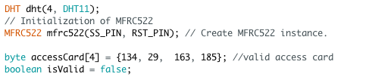

**Figure 1. Initialization**

4. Read the card by approaching the RFID knob to the module and activate sound and motor for the valid card:

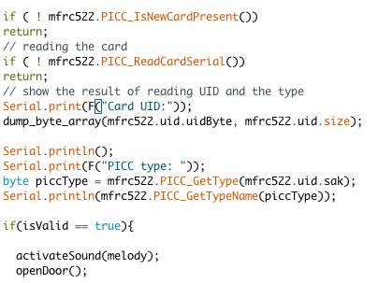

**Figure 2. Check card ID**

5. The body of methods:

Before starting to check the validity of ID the right ID was read and stored in accessCard[4] array.

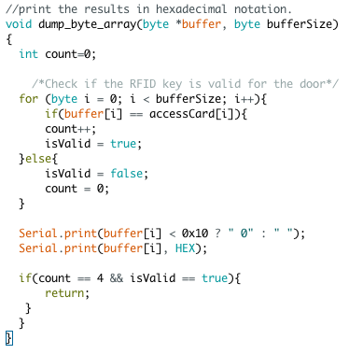

**Figure 3. Check card ID**

tone() function takes the array of notes sound[] parsed by the main and plays this sound. This function is common for all notes.

openDoor() function rotates the door by 180 degree.

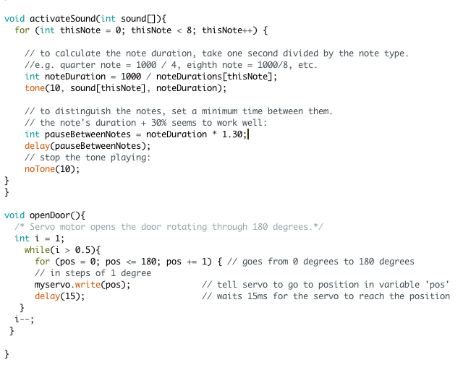

**Figure 4. Activate sound and open the door**

*2. Automatic Lightning*

**Key components:** SunFounder Mega 2560,breadboard, resistor, LED, USB cable, jumper wires, Human Body Infrared Sensor PIR.

Right after the person enters the house with valid ID automatic lightings should be turned on since inside it is usually dark when nobody is there. So when PIR sensor detects human presence LED will be turned on.

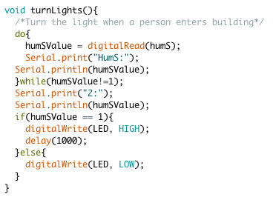

**Figure 4. Turning the lights on in the presence of human**

*3. Monitoring the level of temperature, humidity and the presence of hazardous gases.*

**Key components:** SunFounder Mega 2560,breadboard, resistor, gas sensor, USB cable, jumper wires, speaker, Gas Sensor, Humiture Sensor

In this section the usage of such useful sensors as gas sensor and humiture sensors, which collect data about the level of humidity, temperature and the concentration of certain gases, will be explained. We tested the humiture sensor by holding it in the hound since human body has a property to conduct the heat and the wet paper was used to obtain moisture that can be detected by the sensor. Humiture sensor was connected to digital pin 3.

<TroykaDHT.h> from Arduino collection was included for humiture sensor.

Gas sensor was connected to the analog pin A0. Gas sensor was tested by the smoke from burned paper observing before that in the absence of special gases in the atmosphere the typical value printed by the sensor on the serial monitor is less than 500. Otherwise signalization will be activated.

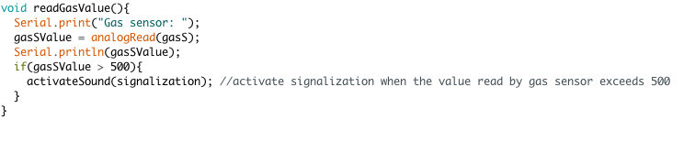

**Figure 5. Reading from the gas sensor**

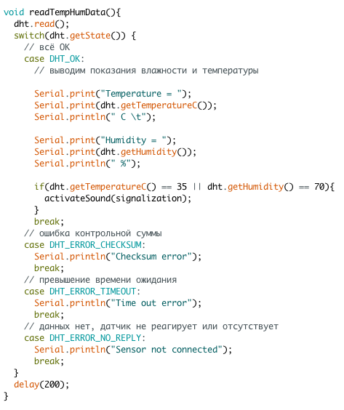

**Figure 6. Reading the temperature and humidity**

Similarly the values printed by the humiture sensor in normal conditions certainly less than 35 degrees for temperature and 70 for humidity. If either of this values exceeds the accepted value signalization will be activated.

*4. Entering the apartment via password*

**Key components:** SunFounder Mega 2560,breadboard, Common Cathode 7 Segment LED Display, USB cable, jumper wires, speaker, switches.

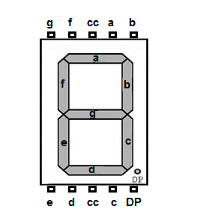

**Figure 7. Common Cathode 7 Segment LED Display [1]**

In this part one single 7 segment LED display with pins on the top and the bottom similar to the one in Figure 7 was used to show the person numbers from 0 to 9. Then 3 switches were used: one switch to increment the number on the display, the second – to decrement and the last one (large switch at the center) to chose the number. Essentially what is happening person enters 4 number one by one and if all 4 numbers are in correct sequence (password) then the melody is played and door to the apartment is not locked anymore.

Originally, the usage of more advanced displays such as VEX display was considered however due to the absence of the equipment it was decided to use 7-segment display.

All pins of the display were connected in order from a to DP to the pins 22-29 on Arduino board. VCC pin was connected to the “+” of breadboard via resistor.

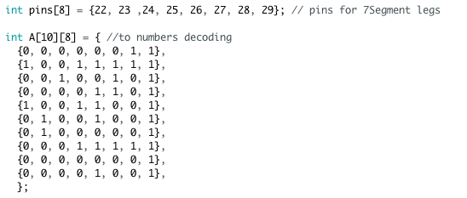

**Figure 8. Matrix for decoding**

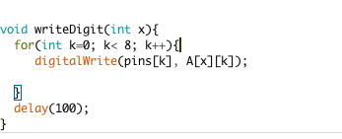

**Figure 9. Writing the digit**

In numbers[] array (Figure 10) we stored each entered digit. Enter event occurs when the central pin is pressed. Then when the count reaches the value of 4 it is compared with the array password[] element by element. If they are equal, sound for the opened door is played. More details of the code can be found in the file with code.

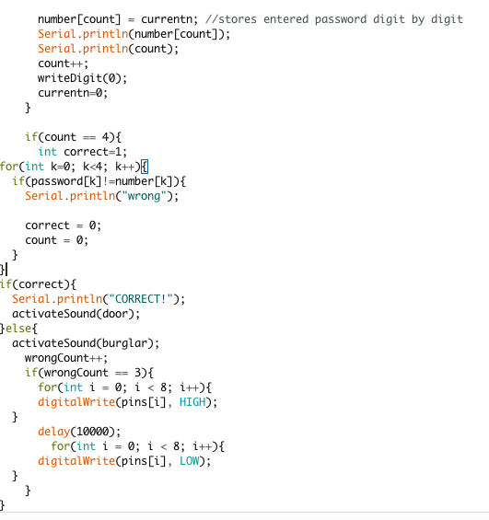

**Figure 10. Reading the password**

**Results**

Having done the project, following results were achieved:

**Table 2. Results**

|  |  |  |  |
| --- | --- | --- | --- |
| **Component** | **Function** | **Purpose** | **Location** |
| RFID RC522 | Identifies the inhabitant through an unique string of characters | For providing with security | Door phone |
| Human Body Infrared Sensor PIR | Detects presence of a human | For turning lights on/off | Inside main entrance |
| RFID Key Fob | Opens the door if the key matches | Serves as a key for the outside door | - |
| Speaker | Emits alarm sounds depending on events | For signalling people about flooding, fire, gas leak, successful entrance, incorrect password | Inside main entrance |
| Humiture Sensor | Measures humidity and temperature | To identify flooding or fire cases | Inside main entrance |
| Gas Sensor | Identifies various types of gases | To let people know whether there is gas leak | Inside main entrance |
| 7 segment LED indicator | Displays digits entered by the user | For setting a new password or entering the existing one. | Inside door |

**Conclusion**

In conclusion, the main objectives of the project were achieved: smart home entrance provides with safety and high level of comfortability. Gas sensor and humiture sensor detects dangerous situations such as smoke, fire or high level of humidity. In case of emergency, sensors spot the danger and speakers warn inhabitants about possible hazard. Moreover, there is a security code for each apartment, which prevents possible trespassers to break into living rooms. To enhance security level RFID were added to the main entrance, so that no trespassers can enter the building. The objective of comfortability was achieved by using motors and PIR sensor. Whenever inhabitant uses RFID key entrance door opens automatically by the assistance of servomotor. PIR sensors sense the presence of inhabitant and bulbs light up automatically. Thus, it can be concluded that the main objectives of the project were achieved; however, the project faced limitations. At the beginning it was planned to work with VEX display and buttons to simulate apartment security system but the only available VEX display was broken and worked incorrectly. The only option was to use seven segment LED and buttons. In general, the project was done correctly and knowledge acquired from this course helped to finish project successfully.

**References**

[1]. Learning About Electronics. (n.d.) *How to Drive a 7 Segment LED Display with an Arduino.* Retrieved April 16, 2018 from <http://www.learningaboutelectronics.com/Articles/Arduino-7-segment-LED-display.php>